Idea Design Schematic - Samie Bencherif RF

Remarkable Functions
DATE 2022-01-27 TYPE TOOL
DESCRIPTION Use a remarkable tablet to create custom button layouts for various computer shortcuts
PROBLEM Keyboard shortcuts can be difficult to remember or execute. They usually require multiple button presses for a single action. The keyboard layout cannot be rearranged, and buttons labels are non-trivial to swap out.
DESIRE I want to use this tool for drawing and 3d modeling programs. I would also use it for text editing in vim. I would explore more potential uses when I have it.
CHALLENGES I am not sure how to program graphics and touch input with the Remarkable.
TECH I expect to C or Python for the desktop programs as they are convenient languages. C is preferred to reduce latency (as I’ve seen in other hardware control projects). On the remarkable I will be limited to where I can find graphics libraries I believe. Likely to be C.
ALTERNATIVES Besides shortcut keys programmed via AHK, there is a potential alternative of using one of my phones as the target controller.
SCOPE I expect 15 work-hours to create a working prototype.

CONCEPT. The illustration shows several interfaces put together. Some specializations include text editing, image editing, window management, app launching, 3d navigation, and macros
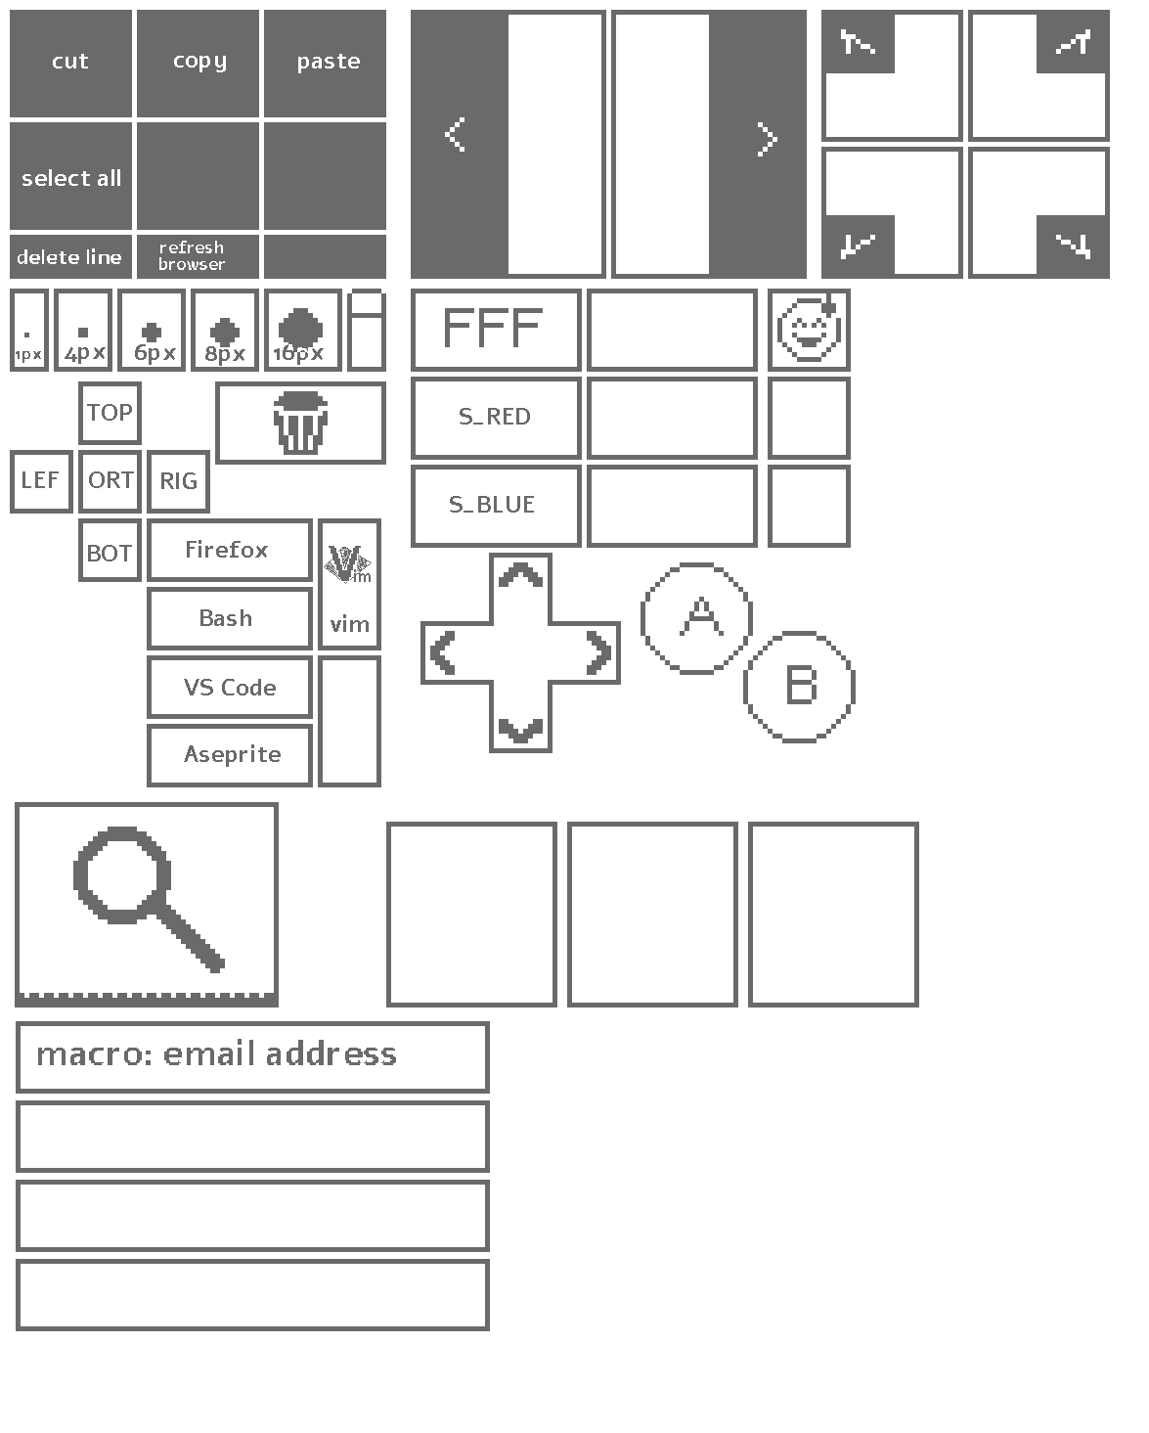
CLOSING I only included a view direction and perspective/orthogonal widget. 3D navigation could be greatly expanded by including various pads that take 2d input much like a trackpad but each interpret the information differently. One pad could be for rotations, another could be for orbiting. A pad could be used for the mouse.
It would be an interesting experiment to attempt to fully emulate the keyboard and mouse.
Using a phone instead of the tablet has the bonus of color support, fast changing display, and light emission.
The phone has the disadvantages of light emission, high power use, smaller surface, and, if the iphone is used I would be forced to use “poll-streaming” for communication which would be loads slower than serial.

